# ABC Inventory Management

# Test Scenario: Send Product Scenario

# Scenario Description

This scenario is intended to test the Send Product functionality of the system. In this scenario a staff from a particular location logs in using their username and password. After this the staff uses the send functionality of the system. The staff however cannot accept the product themselves. This is an important functionality as this system allows a staff to send a product to another location in the system then send it physically using an external delivery service like TOLL or TNT.

# Version Control

|  |  |  |  |
| --- | --- | --- | --- |
| Version Number | Date | Author | Description |
| 10.0 | 13/09/2018 | Shirish Maharjan | Initial Draft |
| 10.1 | 14/09/2018 | Shirish Maharjan | First Version (Iteration 5) |

# Test Scripts

The following are the test scripts that will cover this scenario:

* SP001 Send Product Script

# Use Case

The use case covered by this test scenario is as follows:

* Send Product

# Test Components/ Requirements

This test scenario covers the following high-level testing requirements:

* Test the Send Product functionality of the system.

# User Groups

* Staff (User)

# Test Scripts

The following are the elaboration of the test script mentioned above:

# SP001: Send Product Script

## Script Description

This script follows each step while sending a product to another location then attempting to accept it through the same account. This script will check if each step while sending the product is a success. If any step fails to succeed, bug will be reported, and the test will be conducted again.

## Testing Requirements

This test will cover the Send Product functionality of the system.

## Setup

* The computer in the location is powered on.
* Make sure the computer is connected to the internet.
* Application is launched.
* Username and password are known.

## Teardown

* Product can be accepted in the destination location by the staff that belong to the destination location by logging in to the system and then using the Accept Product functionality.

## Script Steps

|  |  |  |  |
| --- | --- | --- | --- |
| Step | Test Action | Expected Results | Pass/Fail |
| 1. | Application is launched. | System displays the ‘Login’ Page with the Username and Password field empty. | Pass |
| 2. | Enter username and password in the username and password field. | System waits till user to click on ‘Login’ button. | Pass |
| 3. | Click on the ‘Login’ button. | System grants access to the user and opens the Homepage | Pass |
| 4. | Click on the ‘Send Product’ button. | System launches the ‘Send Product’ page. | Pass |
| 5. | Select a location to send the products to. | System waits for the user’s action. | Pass |
| 6. | Enter a description for the transfer being made. | System waits for the user’s action. | Pass |
| 7. | Select product if it is already displayed in the Table View and the click on the ‘->’ button to add the product to the cart. | System adds the selected product to the cart with quantity as 1. | Pass |
| 8. | Double click on the quantity of the cart to change the quantity to be sent and press enter. | System changes the quantity value in the cart. | Pass |
| 9. | Enter product item (size) code in the search section and click on the ‘Search’ button. | Display the product item (size) if it exists in the location that the staff logged in belongs to. | Pass |
| 10. | Repeat Step 7 and 8. | Repeat Step 7 and 8. | Pass |
| 11. | Click on the ‘Send Product’ button. | System displays a message saying the Transfer Items have been added. | Pass |
| 12. | Click on ‘Main Menu’ button at the top right corner. | System displays the Homepage | Pass |
| 13. | Click on ‘Accept Product’ button. | System displays the ‘Accept Product’ page but does not display the product that was sent earlier in step 11. | Pass |

### Result Screenshots

**Step 1**

Application launched, and login page is displayed.

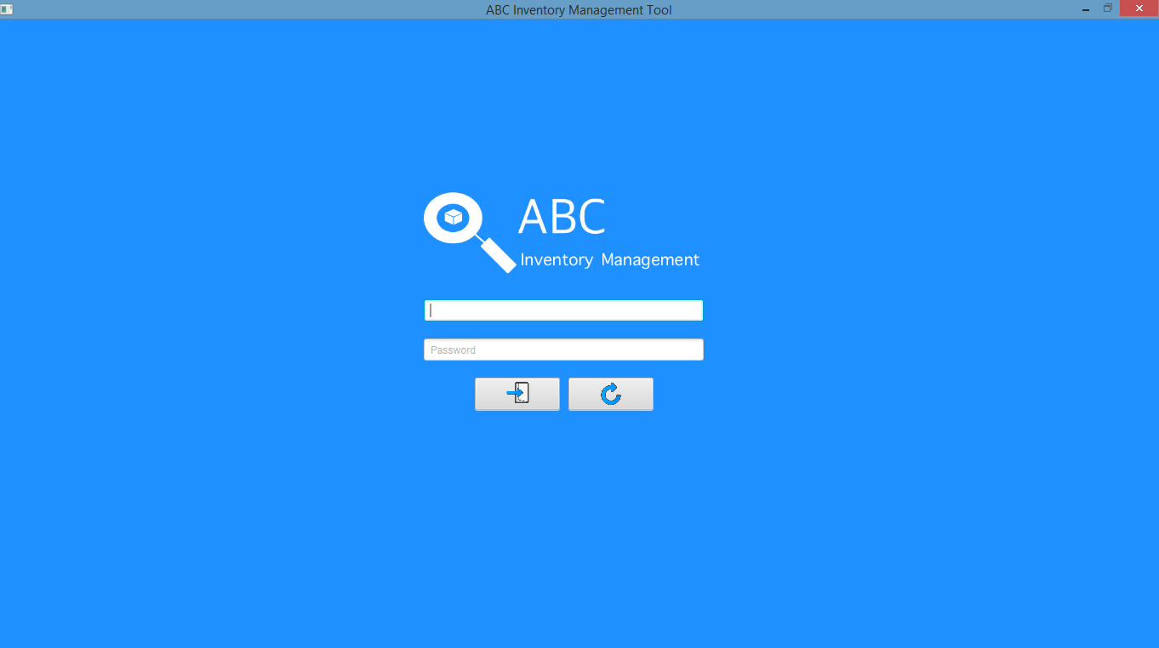

**Step 2**

Username and password are entered, and the system waits user to click on the ‘Login’ button.

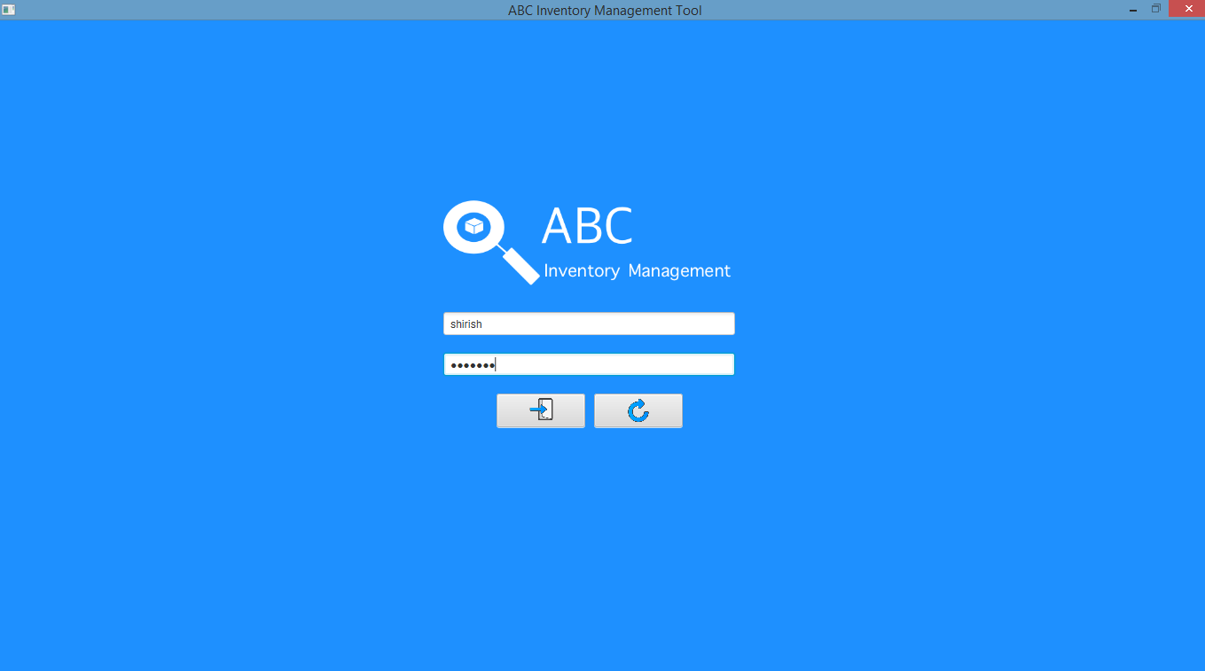

**Step 3**

After the ‘Login’ button is pressed at step 3, access is granted, and the Homepage is displayed.

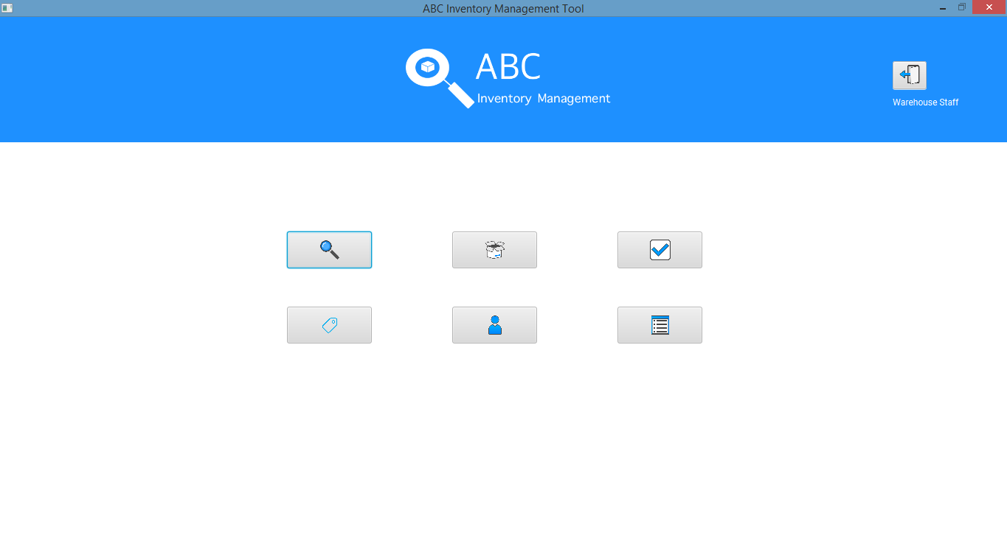

**Step 4**

After the user clicks on the ‘Send Product’ button the ‘Send Product’ page is displayed.

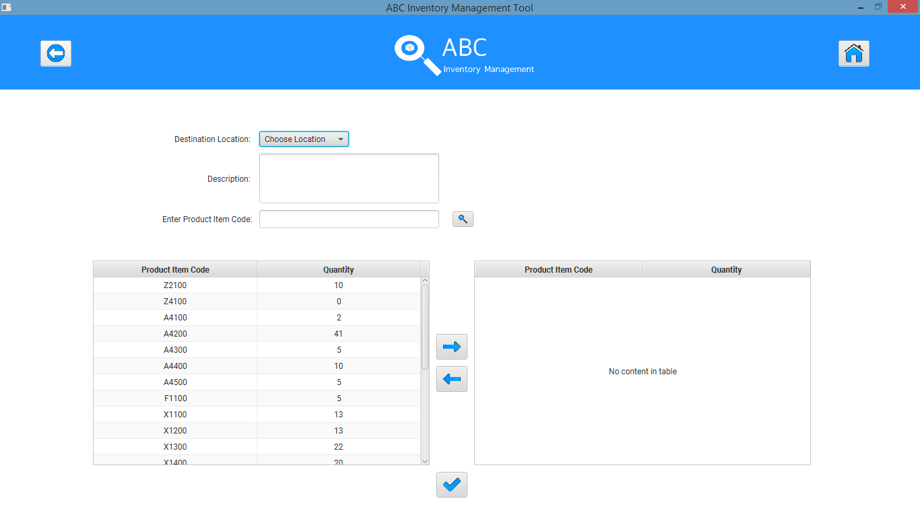

**Step 5**

‘Oxford Store’ is selected as the destination location.

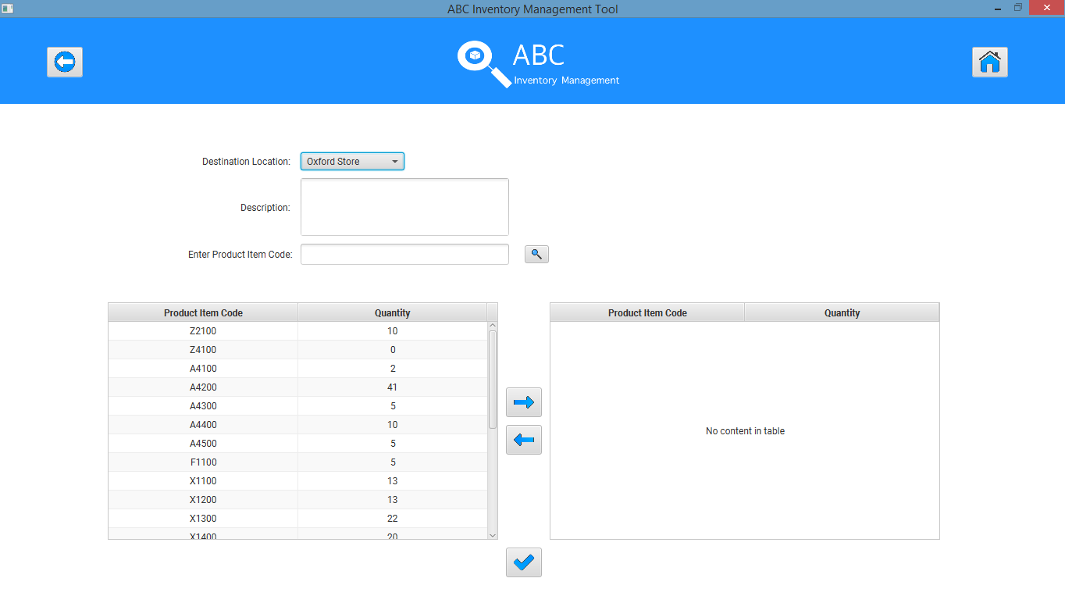

**Step 6**

A description is entered for the transfer.

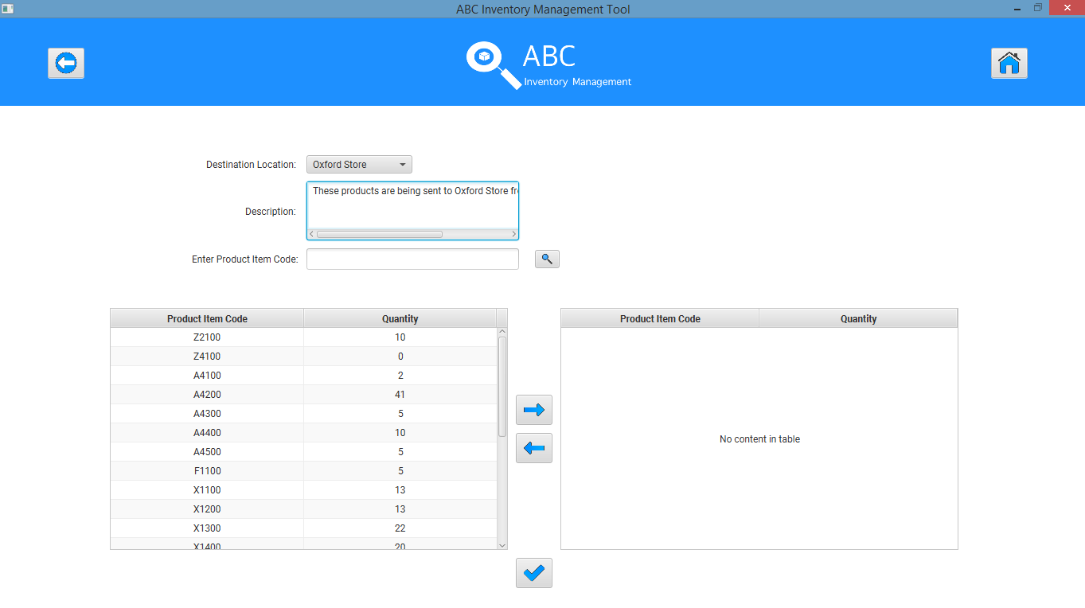

**Step 7**

A product if it is already displayed in the list is selected.

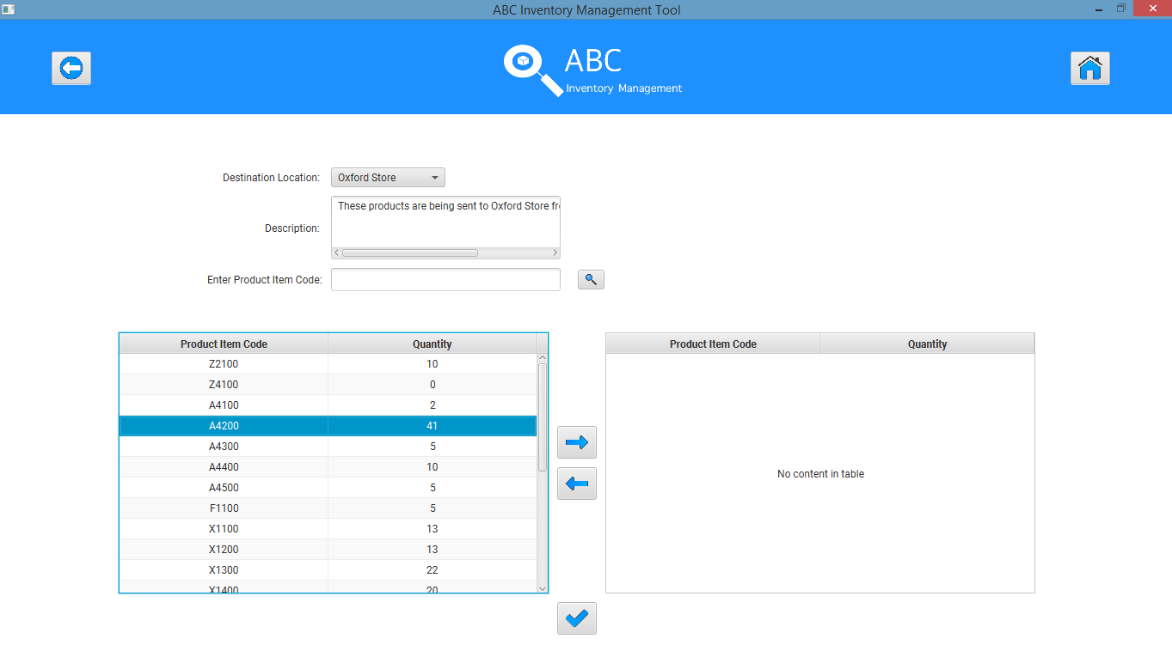

‘->’ button is clicked to add the product to the cart with quantity 1.

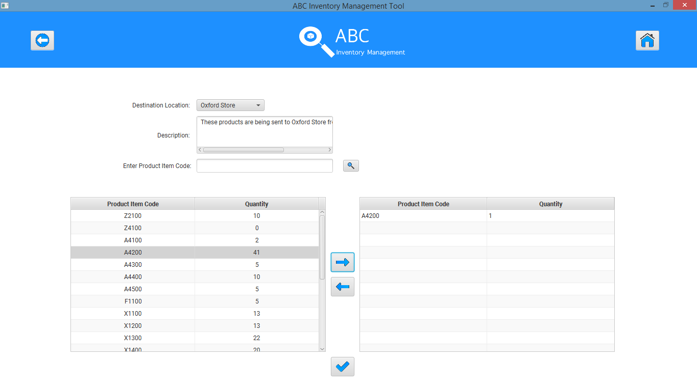

**Step 8**

Quantity in the cart side is double clicked which makes it editable.

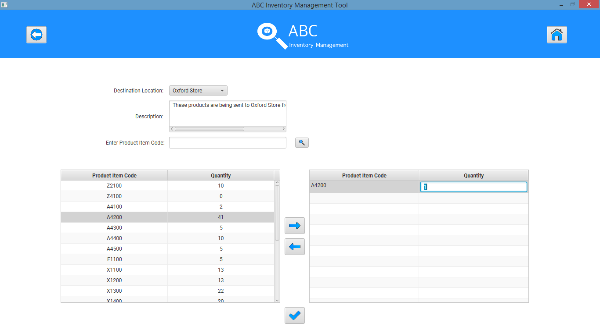

Quantity that is wished to be sent is entered and enter key is pressed.

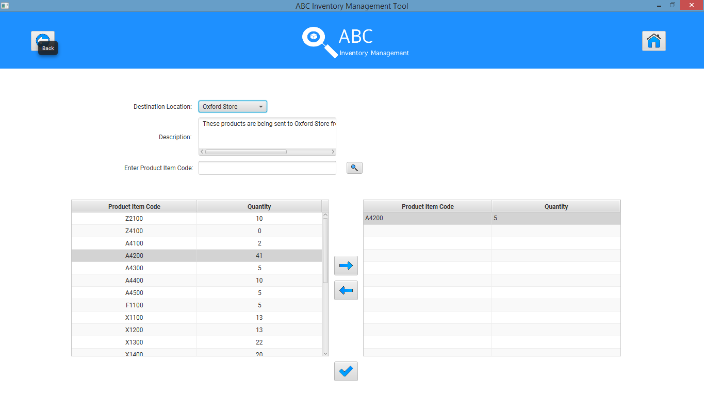

**Step 9**

A product item code (L2100) (XS) is entered in the search field and the search button is clicked.

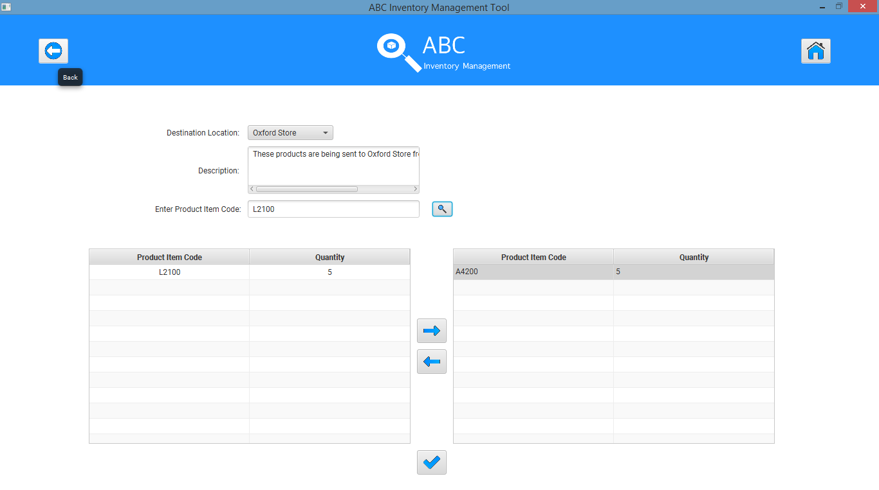

**Step 10**

Add the size to the cart but leave the quantity as 1.

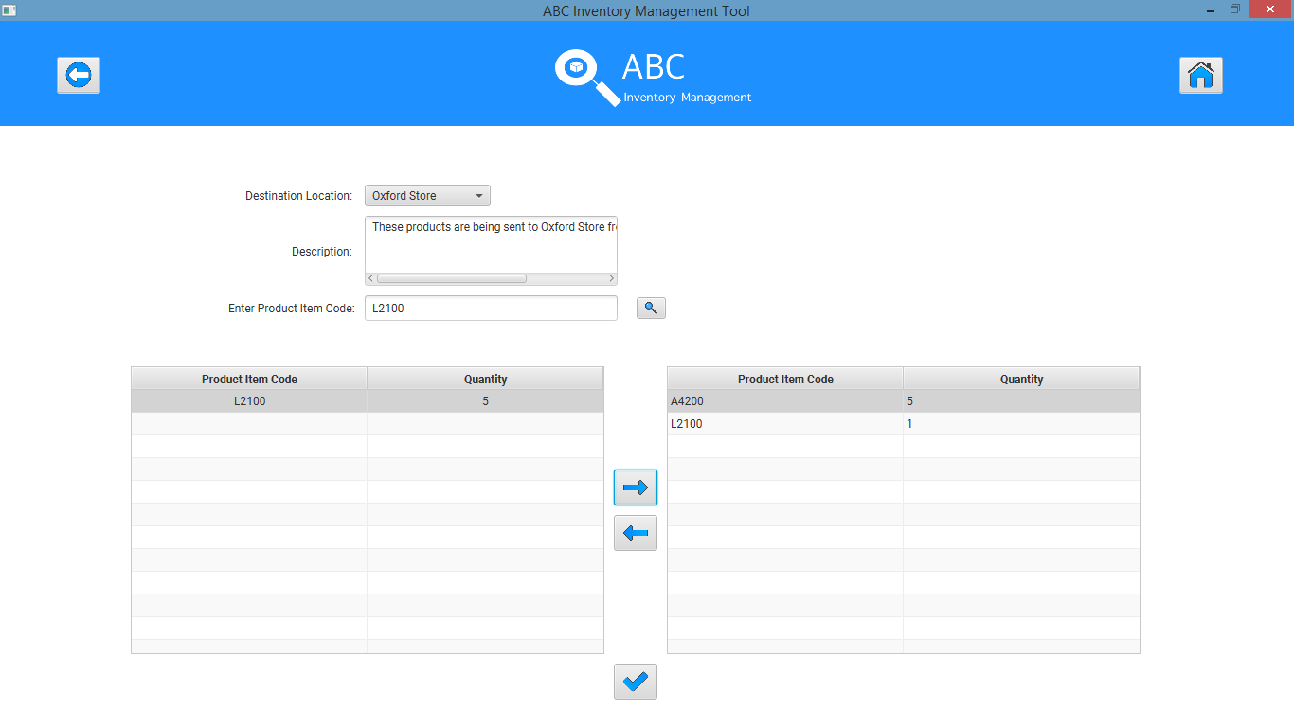

**Step 11**

Message displayed by the system.

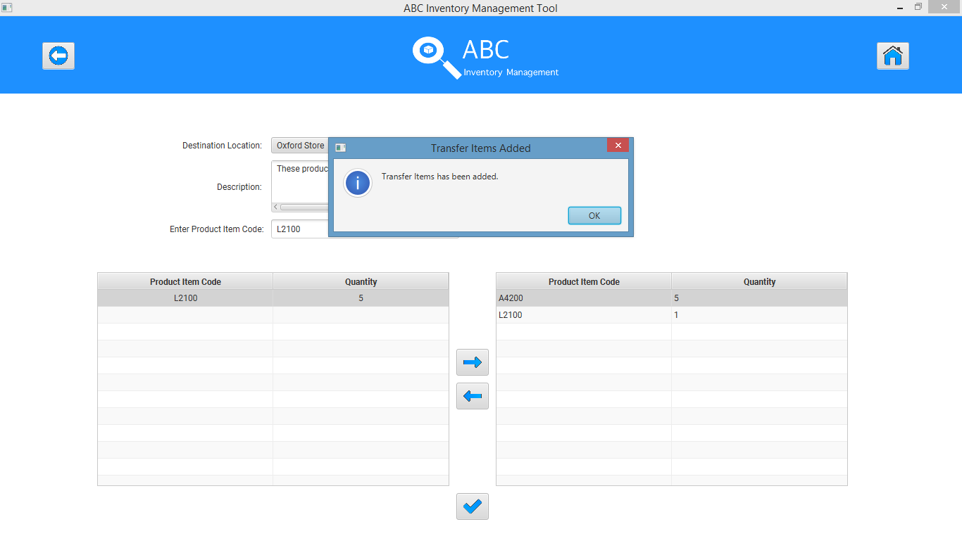

**Step 12**

Homepage after the user clicks on the ‘Main Menu’ button.

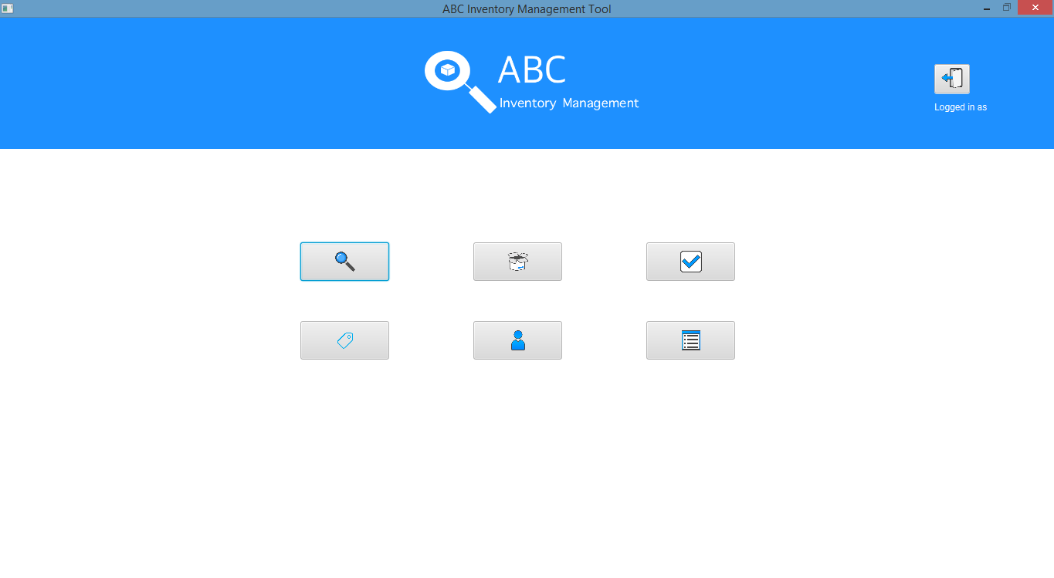

**Step 13**

Empty ‘Accept Product’ page because the user a warehouse staff sent the products from warehouse to a store. Only the staff belonging to the destination location can view the transfer.

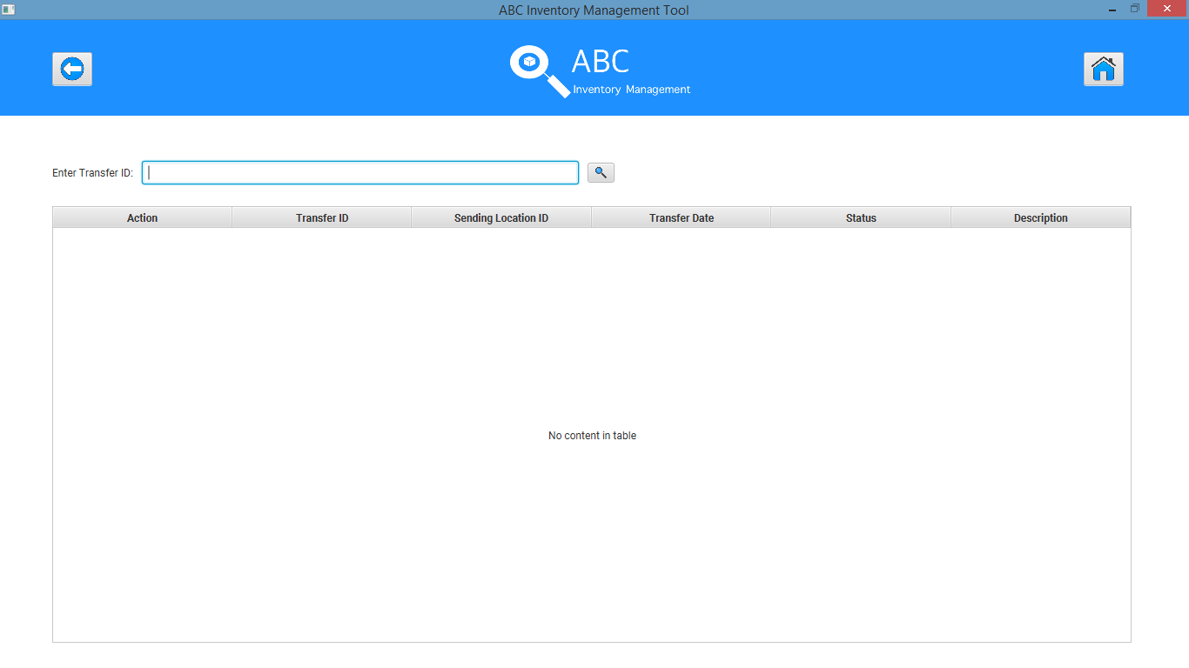

The quantity being adjusted from the sending location ‘Newtown Warehouse’:

A4200 quantity in Newtown warehouse was 41. After 5 items were sent to Oxford Store the quantity has been adjusted to 36.

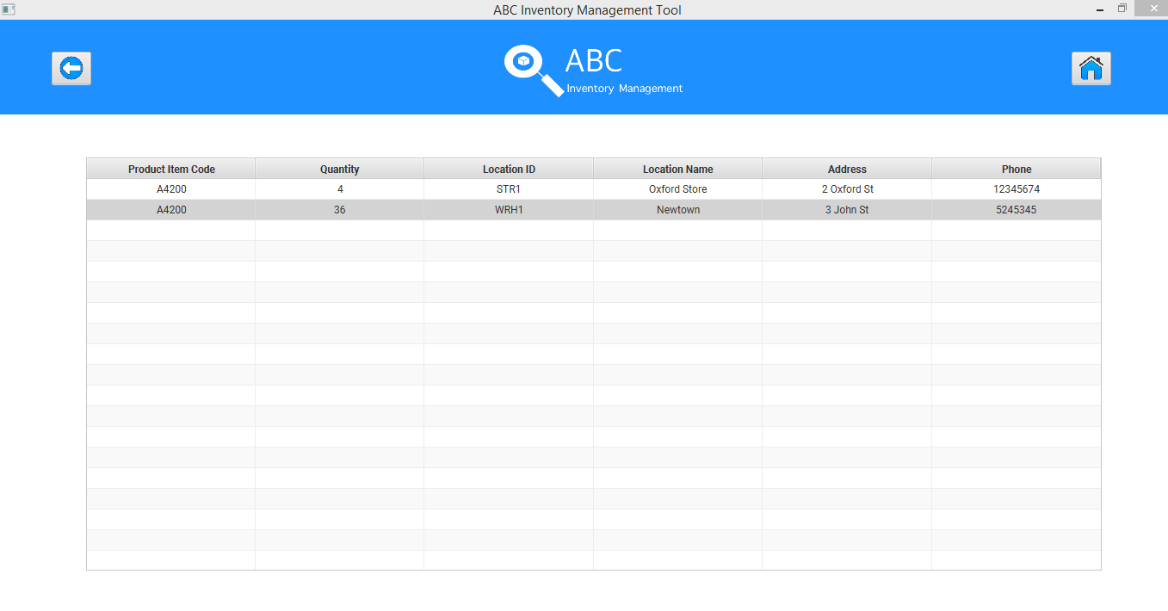

L2100 quantity in Newtown warehouse was 5. After 1 item was sent to Oxford Store the quantity has been adjusted to 4.

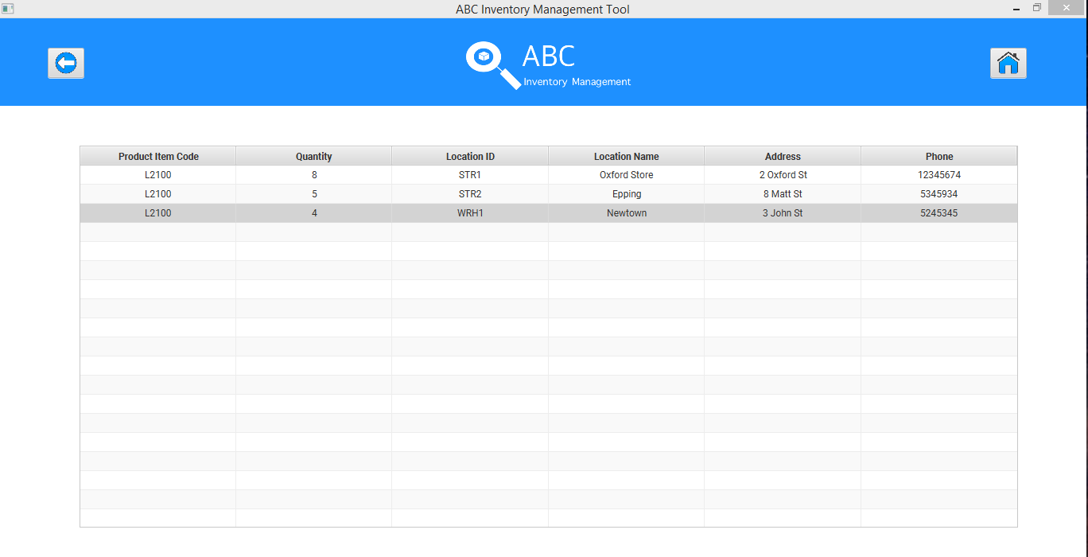

## Test Execution

|  |  |  |  |  |
| --- | --- | --- | --- | --- |
| Date/Time | Tester | Test ID | Test Phase | Status |
| 14/09/2018 | Shirish Maharjan | SM001 | Cycle 1 | Pass |